Pizza Sales SQL Queries
A)KPI’s
1) Total Revenue
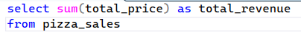
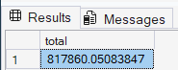
2) Average order value
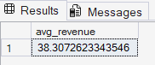
3) Total Pizza Sold
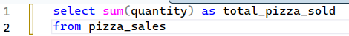
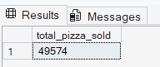

4) Total orders
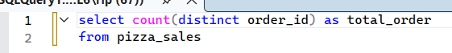
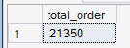
5) Average pizza per order
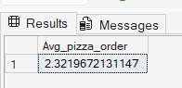
6) Monthly trend for total orders
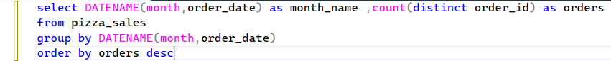
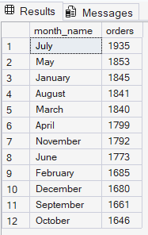
7) Daily trend for total orders
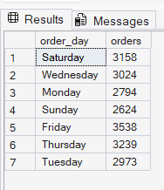
7) Percentage of sales by pizza category
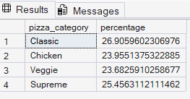
7) Percentage of sales by pizza size
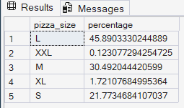
8) Top 5 pizzas by revenue
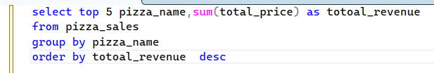
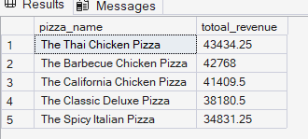

8) Bottom 5 pizzas by quanitty
